**Screenshots for Network Topology 2**

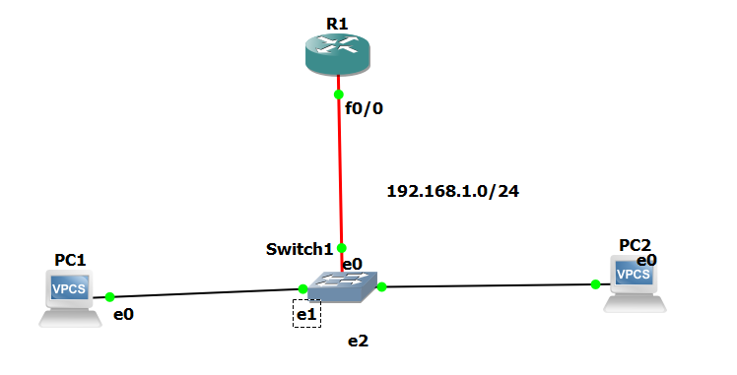

**Screenshots for Router Configuration**

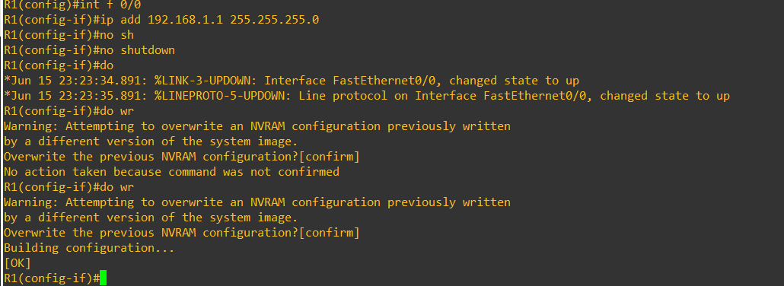

**Screenshots for PC1 configuration**

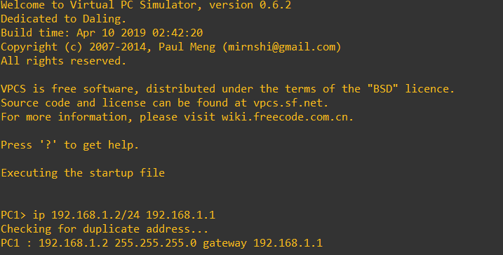

**Screenshots for PC2 Configuration**

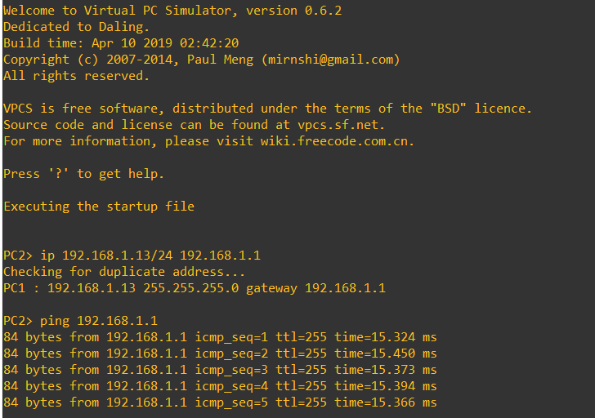

**Ping PC2 from PC1**

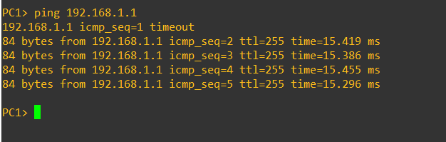

**Ping PC1 from PC2**

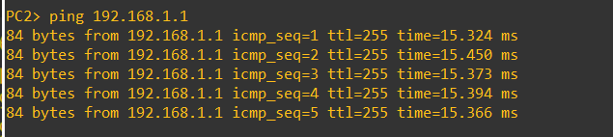

**Ping through Router**

